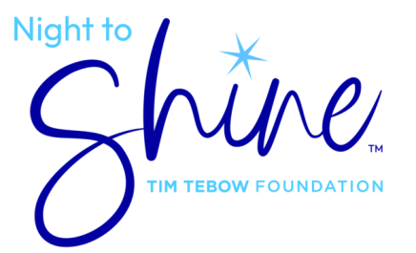

Volunteer Permission Slip (Volunteers Ages 13 - 18)

I give my permission for __________________________________ to participate as a volunteer
at the 2026 Night to Shine, sponsored by the Tim Tebow Foundation at Living Hope Community Church
Doylestowm on Friday, February 13, 2026.

Volunteer Information
DOB: ________________________ Gender: Female: ____ Male: ____
Address:_____________________________________________________________________
City: _______________________________ State: ________ Zip Code: _________________
Phone: ______________________________
Parent / Guardian Phone (Home):_______________________________________________
Parent / Guardian Phone (Cell):_________________________________________________
Desired Volunteer Role: ________________________________________________________
Parent Signature: _____________________________________ Date: _________________
Parent Printed Name: _________________________________________________________
I acknowledge that the signature above is my parent or guardian’s signature. They
have viewed this form and consented to my participation in the Night to Shine event.
Remit form to: nts@livinghopepa.org -or- bring to training session

